Niger

## Population Data

The data set shows the political stability estimate of the country each year.

## # A tibble: 23 x 5  
## country iso3c date population popCategory5  
## <chr> <chr> <dbl> <dbl> <chr>   
## 1 Niger NER 1996 9826598 small   
## 2 Niger NER 1997 10178201 small   
## 3 Niger NER 1998 10545716 small   
## 4 Niger NER 1999 10929918 small   
## 5 Niger NER 2000 11331557 small   
## 6 Niger NER 2001 11751365 small   
## 7 Niger NER 2002 12189983 small   
## 8 Niger NER 2003 12647984 small   
## 9 Niger NER 2004 13125916 small   
## 10 Niger NER 2005 13624467 small   
## 11 Niger NER 2006 14143971 small   
## 12 Niger NER 2007 14685399 small   
## 13 Niger NER 2008 15250908 small   
## 14 Niger NER 2009 15843133 small   
## 15 Niger NER 2010 16464025 small   
## 16 Niger NER 2011 17114761 small   
## 17 Niger NER 2012 17795191 small   
## 18 Niger NER 2013 18504255 small   
## 19 Niger NER 2014 19240157 small   
## 20 Niger NER 2015 20001663 small   
## 21 Niger NER 2016 20788838 small   
## 22 Niger NER 2017 21602472 small   
## 23 Niger NER 2018 22442948 small

# Population growth data

## # A tibble: 23 x 5  
## country iso3c date popGrowth popGrowthCat5   
## <chr> <chr> <dbl> <dbl> <chr>   
## 1 Niger NER 1996 3.48 high growth rate  
## 2 Niger NER 1997 3.52 high growth rate  
## 3 Niger NER 1998 3.55 high growth rate  
## 4 Niger NER 1999 3.58 high growth rate  
## 5 Niger NER 2000 3.61 high growth rate  
## 6 Niger NER 2001 3.64 high growth rate  
## 7 Niger NER 2002 3.66 high growth rate  
## 8 Niger NER 2003 3.69 high growth rate  
## 9 Niger NER 2004 3.71 high growth rate  
## 10 Niger NER 2005 3.73 high growth rate  
## 11 Niger NER 2006 3.74 high growth rate  
## 12 Niger NER 2007 3.76 high growth rate  
## 13 Niger NER 2008 3.78 high growth rate  
## 14 Niger NER 2009 3.81 high growth rate  
## 15 Niger NER 2010 3.84 high growth rate  
## 16 Niger NER 2011 3.88 high growth rate  
## 17 Niger NER 2012 3.90 high growth rate  
## 18 Niger NER 2013 3.91 high growth rate  
## 19 Niger NER 2014 3.90 high growth rate  
## 20 Niger NER 2015 3.88 high growth rate  
## 21 Niger NER 2016 3.86 high growth rate  
## 22 Niger NER 2017 3.84 high growth rate  
## 23 Niger NER 2018 3.82 high growth rate

## Population trend

The plot shows the population trend of the country.

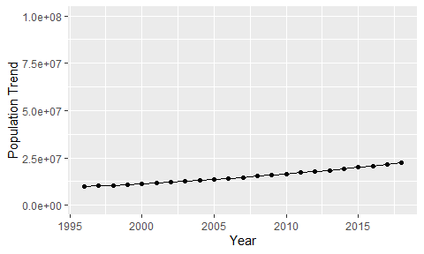

Political Stability Trend

# Population growth trend

The plot shows the population growth rate trend of the country.

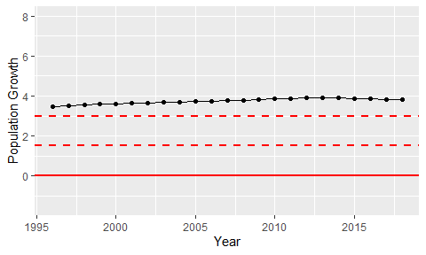

Population Growth Trend